

Nithiesh kumar M
CH.SC.U4CSE24230
Week – 4

Design and Analysis of Algorithm(23CSE211)

1. BST Balancing using Rotation Method
Code:
#include <stdio.h> #include <stdlib.h> struct Node { int key;
struct Node *left, *right; int height;
};
int max(int a, int b) { return (a > b) ? a : b; }
int getHeight(struct Node *n) { return (n == NULL) ? 0 : n->height; } struct Node* newNode(int key) {
struct Node* node = (struct Node*)malloc(sizeof(struct Node)); node->key = key;
node->left = node->right = NULL; node->height = 1; return node;
}
struct Node *rightRotate(struct Node *y) { struct Node *x = y->left; struct Node *T2 = x->right; x->right = y; y->left = T2;
y->height = max(getHeight(y->left), getHeight(y->right)) + 1; x->height = max(getHeight(x->left), getHeight(x->right)) + 1; return x;
}
struct Node *leftRotate(struct Node *x) { struct Node *y = x->right; struct Node *T2 = y->left; y->left = x; x->right = T2;
x->height = max(getHeight(x->left), getHeight(x->right)) + 1; y->height = max(getHeight(y->left), getHeight(y->right)) + 1; return y;
}
struct Node* balanceTree(struct Node* node) { if (node == NULL) return NULL; node->left = balanceTree(node->left); node->right = balanceTree(node->right);
node->height = 1 + max(getHeight(node->left), getHeight(node->right)); int balance = getHeight(node->left) - getHeight(node->right); if (balance > 1 && getHeight(node->left->left) >= getHeight(node->left-
>right)) return rightRotate(node);
if (balance > 1 && getHeight(node->left->left) < getHeight(node->left-
>right)) {
node->left = leftRotate(node->left); return rightRotate(node);
}
if (balance < -1 && getHeight(node->right->right) >= getHeight(node->right-
>left)) return leftRotate(node);
if (balance < -1 && getHeight(node->right->right) < getHeight(node->right-
>left)) {
node->right = rightRotate(node->right); return leftRotate(node);
}
return node;
}
void printGivenLevel(struct Node* root, int level) { if (root == NULL) return;
if (level == 1) printf("%d ", root->key); else if (level > 1) {
printGivenLevel(root->left, level - 1); printGivenLevel(root->right, level - 1);
} }
void printLevelOrder(struct Node* root) { int h = getHeight(root); for (int i = 1; i <= h; i++) { printGivenLevel(root, i); printf("| ");
} } int main() {
printf("CH.SC.U4CSE24230\n"); struct Node *root = newNode(157); root->left = newNode(110); root->left->right = newNode(147); root->left->right->left = newNode(122); root->left->right->right = newNode(149); root->left->right->right->right = newNode(151); root->left->right->left->left = newNode(111); root->left->right->left->right = newNode(141); root->left->right->left->left->right = newNode(112); root->left->right->left->right->left = newNode(123); root->left->right->left->right->left->right = newNode(133); root->left->right->left->left->right->left = newNode(117); root = balanceTree(root); printf("AVL Level Order: "); printLevelOrder(root); printf("\n"); return 0;
}

Output: 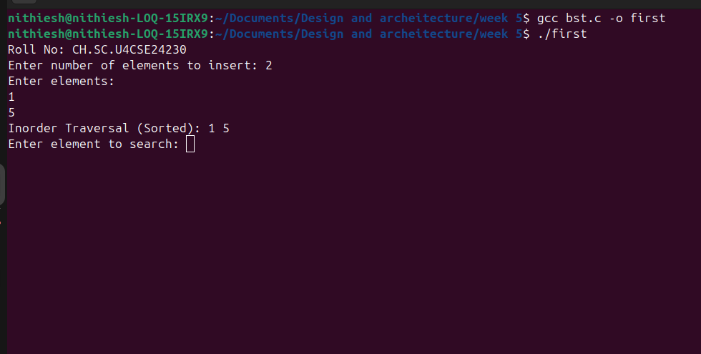

Time Complexity: O(n)
Justification: The balanceTree function is called once on the root, but it recursively visits every node in the tree exactly once to calculate heights and perform rotations. Since the code manually builds a tree with n nodes and then runs a single post-order traversal to balance it, the time taken is proportional to the number of nodes.

